Achievement Period
Achievements by nominees will only be considered if they have occurred during the achievement period 1 July 2021 to 30 June 2022

Angler of the Year Nomination Form
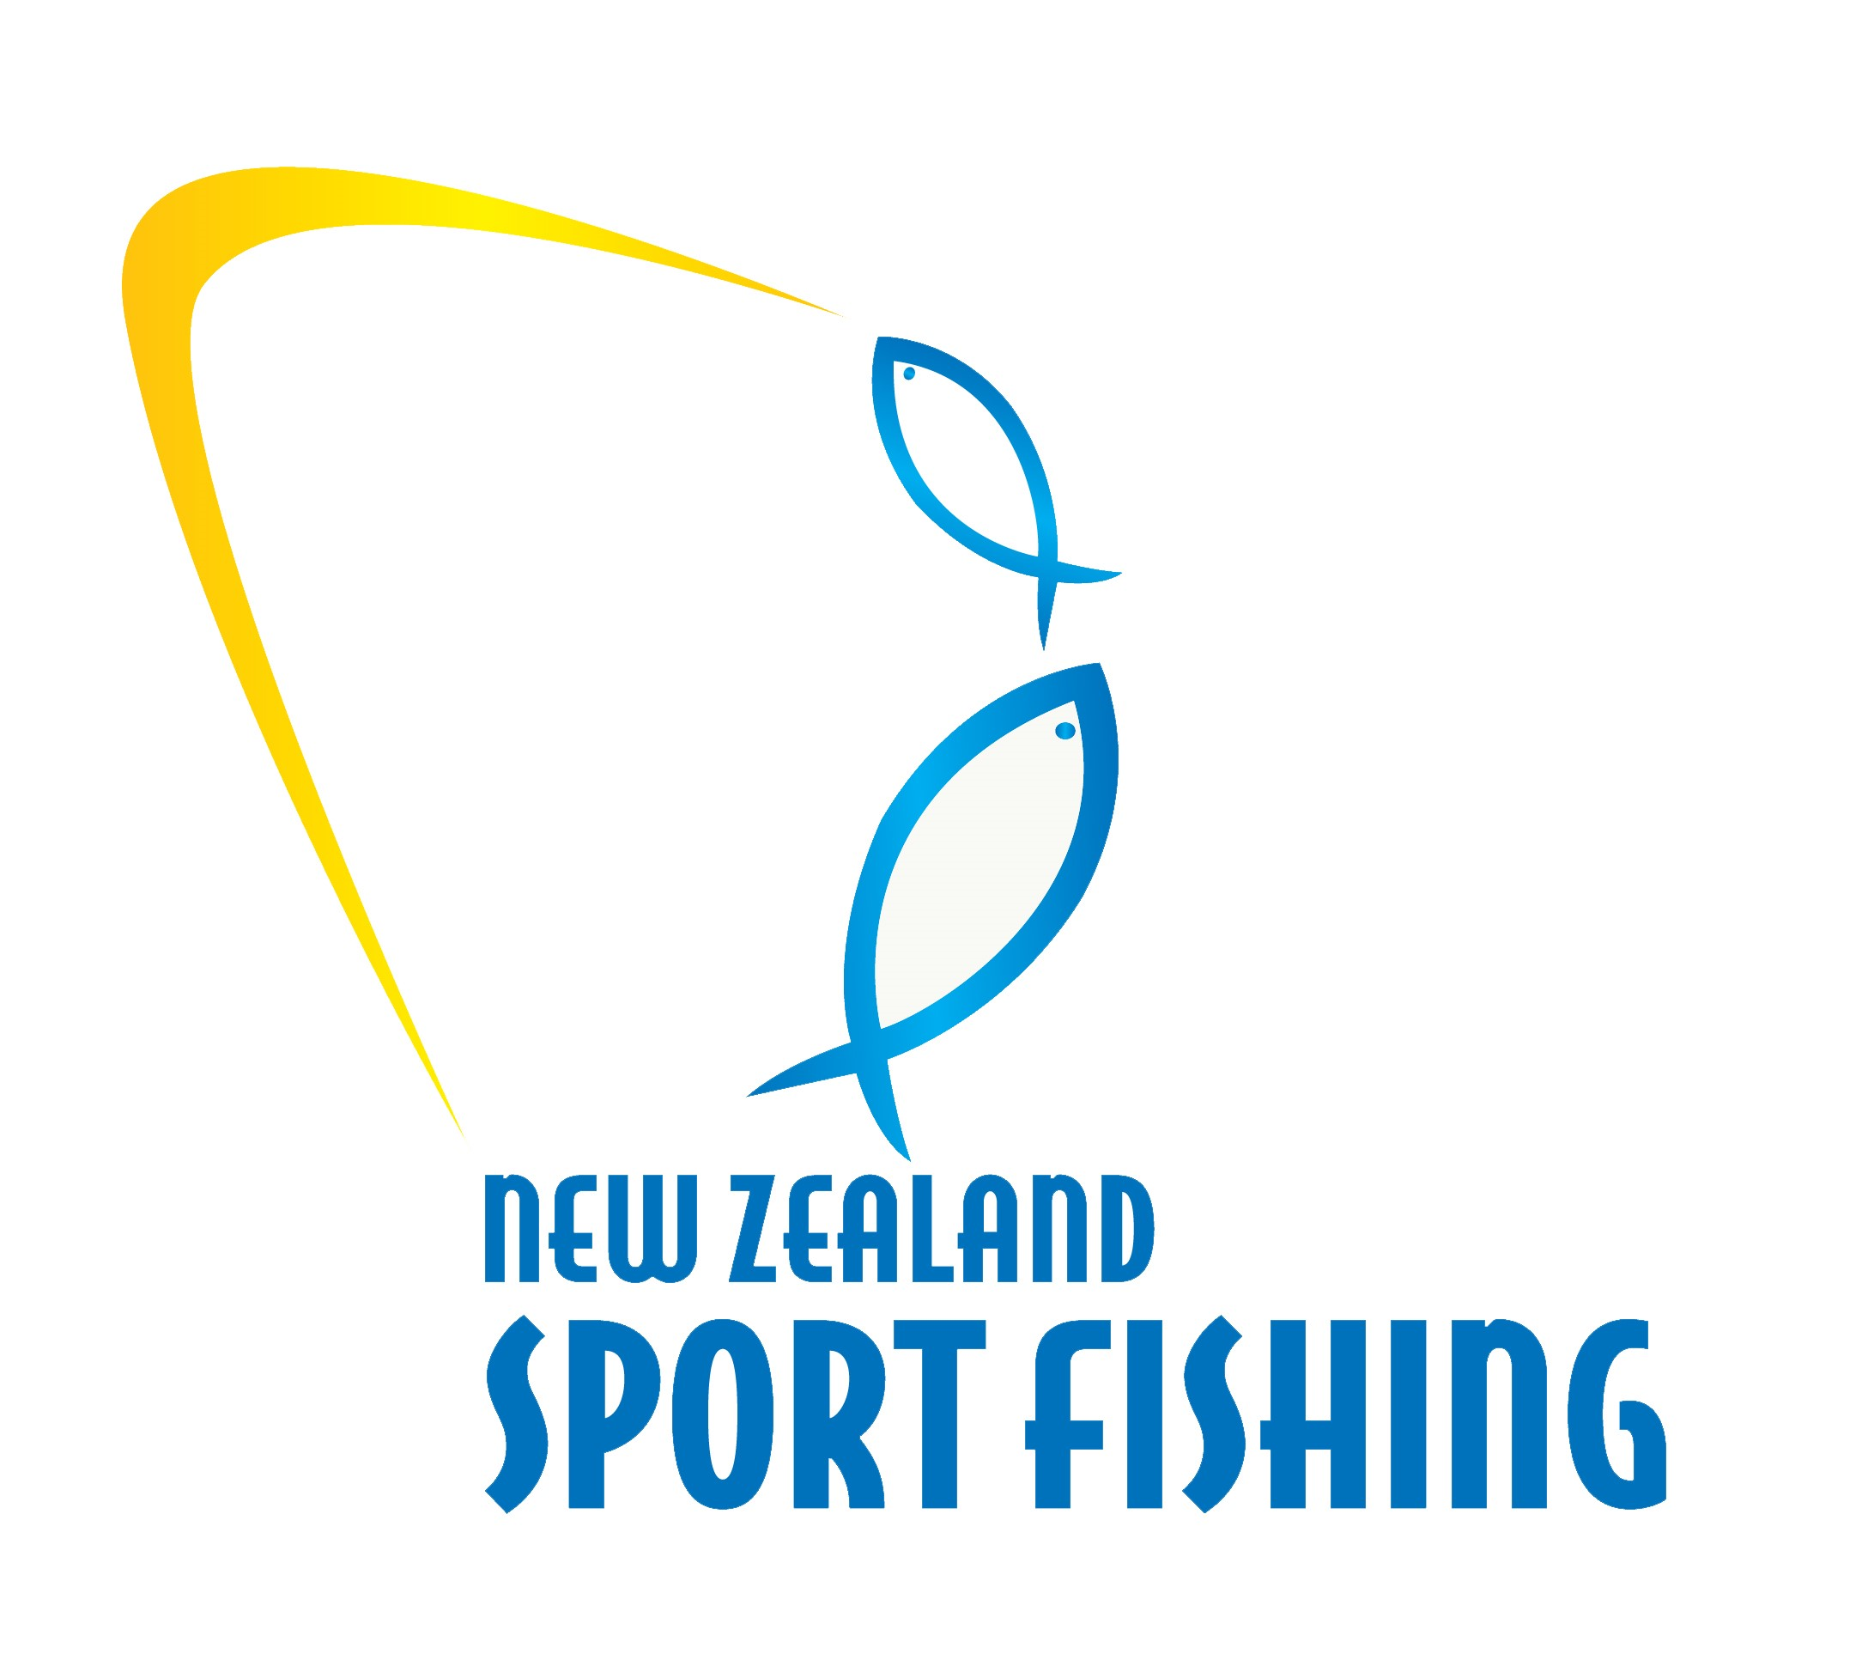
ANGLER OF THE YEAR
Open to all anglers that have competed successfully at Club, National and International level, and contributed to the sport of Sport Fishing.
NOMINEE’S DETAILS
Nominee Name:
Nominee Address:
Email Address: Phone / Work:
Is the Nominee aware of the Nomination: Yes No
NOMINATED BY
Name: Relationship:
Email Address: Phone Home / Work:
NOMINEE ACHIEVEMENTS
Significant Club or Regional achievements within the achievement period, including Club competitions and new Club Records established:

National achievements within the achievement period, including National Titles won and new National Records established:

International achievements within the achievement period, including new IGFA World Records:

Nominees greatest achievement within the achievement period:

Please provide an explanation of the achievements above in your own awards
Tell us why in your opinion they deserve to be a winner over and above their achievements listed above. This may include personal background such as charitable work, overcoming adversity or other significant life and sporting achievements outside of the achievement period.

Please ensure the information you provide in the nomination is concise and accurate and provides the judging panel with a clear understanding of the achievements

Awards will be presented to the winner of each category at the New Zealand Sport Fishing Council AGM Awards Dinner at Bay of Islands Swordfish Club on Saturday 24 September, 2022
Please return your nomination(s) to:
Email: secretary@nzsportfishing.org.nz
New Zealand Sport Fishing Council
PO Box 54 242
Half Moon Bay
Auckland 2144

Nominations must be received before
5pm, Friday 19 August 2022. Please include a photo
If you have one available, of each nominee

