Achievement Period
Achievements by nominees will only be considered if they have occurred during the achievement period 1 July 2021 to 30 June 2022

Club of the Year Nomination Form
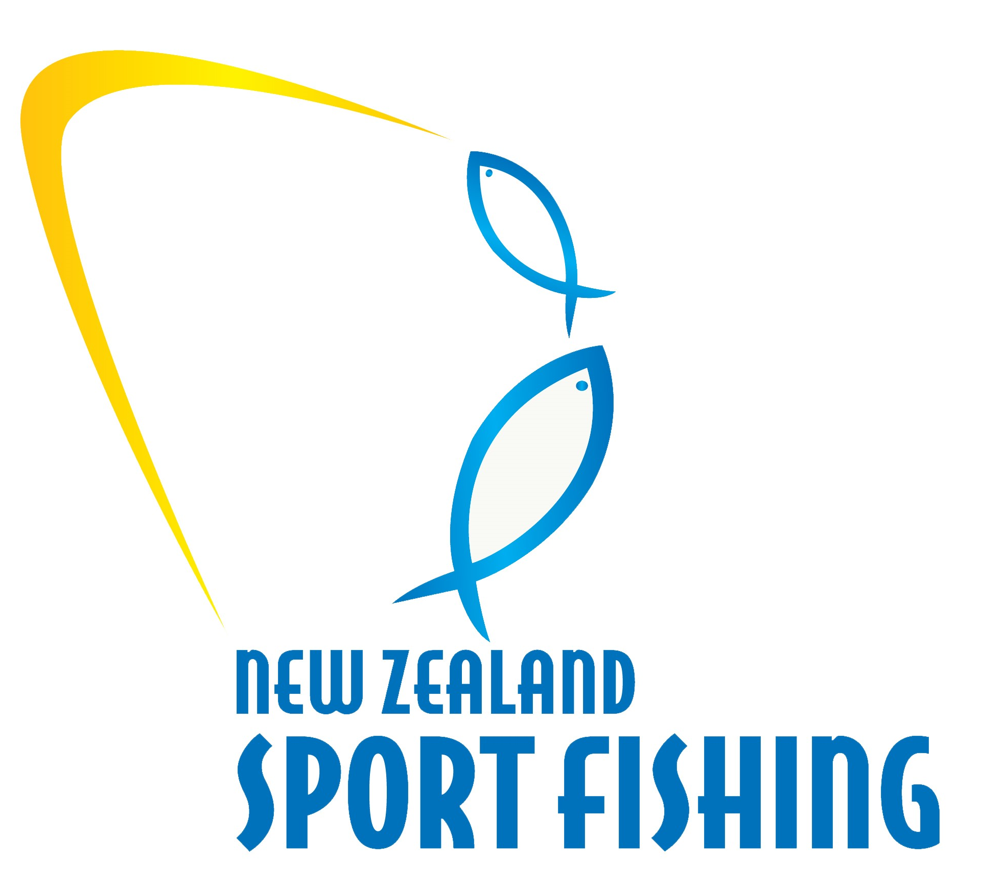
CLUB OF THE YEAR
Open to all clubs that have competed successfully, shown an outstanding ability to provide for its members and contributed to the community.
CLUB DETAILS
Club Name:
Club Address:
Email Address: Phone / Work:
NOMINEE ACHIEVEMENTS
Effectiveness of the Club – consider structure, planning, volunteers, facilities and training and members.

Tournaments and Competitions – consider the successes of the tournaments held, number of Junior, Senior and Women Anglers engaged and competing. Number of Club members and members from other clubs competing, and new tournaments established.

Contributions to the Community – consider how the greater community are engaged with the club. What schools are engaged through the club through Hiwi the Kiwi and other children’s programs

Contribution to Fisheries Management and Research – consider how the club is engaged with LegaSea and Fisheries Research, including the Tagging Program

Development – consider all areas of new development over the last year, including membership growth, facilities, competition expansion etc

Please ensure the information you provide in the nomination is concise and accurate and provides the judging panel with a clear understanding of the achievements

Awards will be presented to the winner of each category at the New Zealand Sport Fishing Council AGM Awards Dinner at Maraetai Beach Boating Club on Saturday 24 September, 2022
Please return your nomination(s) to:
Email: secretary@nzsportfishing.org.nz
New Zealand Sport Fishing Council
PO Box 54 242
Half Moon Bay
Auckland 2144

Nominations must be received before
5pm, Friday 19 August 2022. Please include a photo
If you have one available, of each nominee

