Achievement Period
Achievements by nominees will only be considered if they have occurred during the achievement period 1 July 2021 to 30 June 2022

Volunteer of the Year Nomination Form
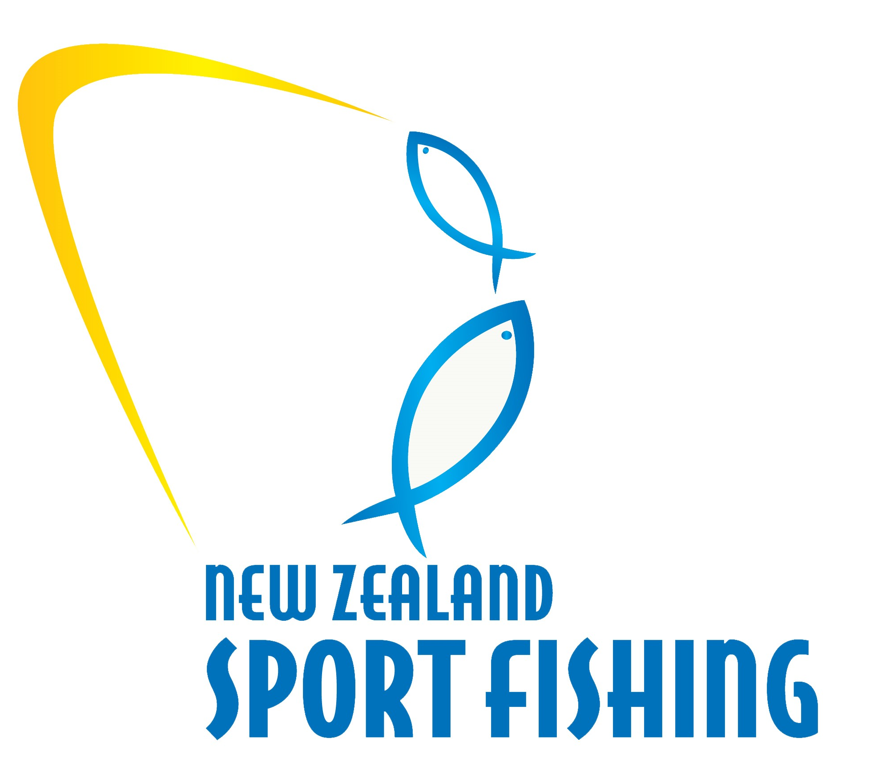
VOLUNTEER OF THE YEAR
Open to all Club Volunteers that have contributed to the sport of Sport Fishing.
NOMINEE’S DETAILS
Nominee Name:
Nominee Address:
Email Address: Phone / Work:
Is the Nominee aware of the Nomination: Yes No
NOMINATED BY
Name: Relationship:
Email Address: Phone Home / Work:
NOMINEE ACHIEVEMENTS
Why do they deserve to win this Award?

Have they done anything specific in the last 12 months that you feel would support this nomination?

Any other information you wish the judges to be aware of?

Please ensure the information you provide in the nomination is concise and accurate and provides the judging panel with a clear understanding of the achievements

Awards will be presented to the winner of each category at the New Zealand Sport Fishing Council AGM Awards Dinner at Maraetai Beach Boating Club on Saturday 24th of September, 2022
Please return your nomination(s) to:
Email: secretary@nzsportfishing.org.nz
New Zealand Sport Fishing Council
PO Box 54 242
Half Moon Bay
Auckland 2144

Nominations must be received before
5pm, Friday 19 August 2022. Please include a photo
If you have one available, of each nominee

